**Rythimic Tunes(React)**

**Table of Contents**

|  |  |
| --- | --- |
| S.no | Title |
| 1. | Introduction:   * Overview * Scenario-Based Introduction * Target Audience * Project Goals and Objectives |
| 2. | **Project Goals and Objectives** |
| 3. | Key Features:   * Song Listings * Playlist Creation * Playback Control * Offline Listening * Search Functionality |
| 4. | Target Audience |
| 5. | Pre-Requisites:   * Node.js and npm * React.js * HTML, CSS, and JavaScript * Version Control (Git) * Development Environment |
| 6. | Project structure |
| 7. | Frontend Code:   * Fetching Songs * Displaying Songs * Audio Playback Management * Wishlist and Playlist Management |
| 8. | **Project Implementation** |
| 9. | Project Flow |
| 10. | Conclusion |

**Introduction:**

**Overview**

Welcome to the future of musical indulgence with RhythmicTunes, a cutting-edge music streaming application built using React.js. This application offers a seamless and immersive audio experience, blending innovation with user-centric design. Whether you're discovering the latest hits or revisiting timeless classics, RhythmicTunes ensures a personalized musical journey tailored to your tastes.

RhythmicTunes is an innovative music streaming application developed using React.js, designed to enhance the user’s music listening experience. This application provides seamless audio playback, personalized playlists, and a dynamic interface that makes discovering and enjoying music more engaging. The project aims to redefine how users interact with digital music, offering a smooth and visually appealing interface.

**Scenario-Based Introduction**

Imagine walking through a bustling city street, surrounded by the sounds of life. You open RhythmicTunes on your phone, and with just a few taps, you're transported into a world of music perfectly curated for your mood. The app's smart playlist starts with an upbeat pop song, shifting to a relaxing indie track as you board the train, making your commute a delightful experience.

****Project Goals and Objectives:****

**The primary goal of RhythmicTunes is to create a seamless and immersive music streaming platform that caters to the needs of music enthusiasts, casual listeners, and tech-savvy users. The application aims to provide a personalized and enjoyable music experience by leveraging modern web technologies and user-centric design principles.**

**The RhythmicTunes project is designed to provide a modern, user-friendly, and feature-rich music streaming experience. Below is a detailed breakdown of the project's goals and objectives:**

1. ****Song Listings:** Display song details such as title, artist, genre, and release date.**
2. ****Playlist Management:** Users can create, manage, and personalize their playlists.**
3. ****Playback Controls:** Play, pause, skip, and adjust volume effortlessly.**
4. ****Offline Mode:** Download songs to listen offline.**
5. ****Search Functionality**: Easily find songs, artists, or albums.**
6. ****Favorites and Playlists:** Save songs to a favorite list or add them to custom playlists.**

**Key Features:**

1. **Song Listings:** Display a comprehensive list of available songs with details such as title, artist, genre, and release date.
2. **Playlist Creation:** Empower users to create personalized playlists by adding and organizing songs based on their preferences.
3. **Playback Control:** Implement seamless playback control features, allowing users to play, pause, skip, and adjust volume.
4. **Offline Listening:** Allow users to download songs for offline listening, enhancing accessibility and convenience.
5. **Search Functionality:** Provide a robust search feature for users to easily find specific songs, artists, or albums.

**Target Audience:**

RhythmicTunes is designed for a diverse audience, including:

1. **Music Enthusiasts:** Individuals passionate about exploring, discovering, and sharing music.
2. **Casual Listeners:** Users looking for a hassle-free and intuitive music streaming experience.
3. **Playlist Curators:** Users who love creating and organizing playlists for different moods and occasions.

**Pre-Requisites:**

1. **Node.js and npm**

Node.js: A JavaScript runtime environment for running JavaScript code on the server-side.

npm: Node Package Manager for installing and managing dependencies.

Installation: Download and install Node.js and npm from https://nodejs.org/en/download/.

1. **React.js**

React.js: A JavaScript library for building user interfaces.

Installation: Create a new React app using npm create vite@latest and follow the prompts to set up your project.

1. **HTML, CSS, and JavaScript**

Basic knowledge of HTML, CSS, and JavaScript is essential for creating and styling the application.

1. **Version Control (Git)**

Git: A version control system for tracking changes and collaborating on projects.

Installation: Download and install Git from https://git-scm.com/downloads.

1. **Development Environment**

Choose a code editor or IDE such as Visual Studio Code, Sublime Text, or WebStorm.

**Frontend Code:**

1. **Fetching Songs**

* useState: Manage state for items, wishlist, playlist, currently playing audio, and search term.
* useEffect: Fetch data from the server and update state variables.
* Audio Playback: Implement event listeners for managing audio playback.

1. **Displaying Songs**

* Search Functionality: Allow users to search for songs by title, artist, or genre.
* Card Layout: Display songs in a responsive card layout with details and playback controls.
* Wishlist and Playlist Buttons: Add/remove songs from wishlist and playlist.

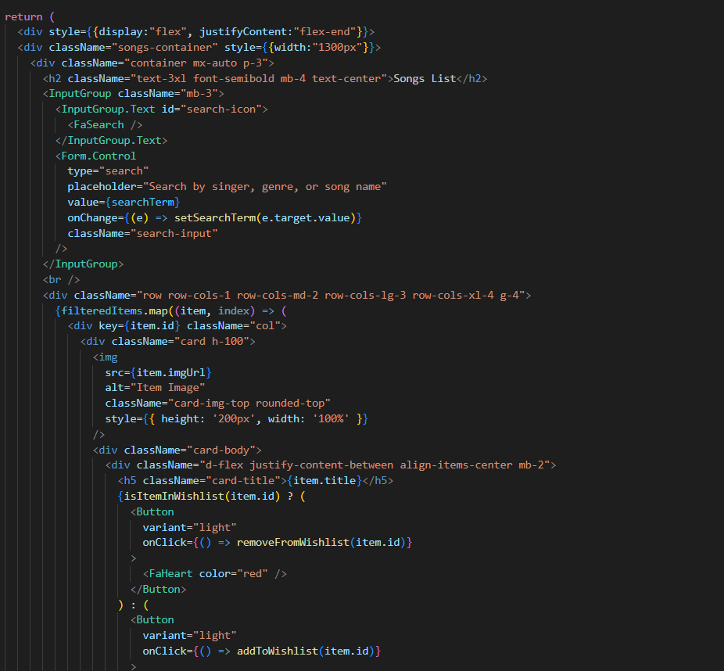

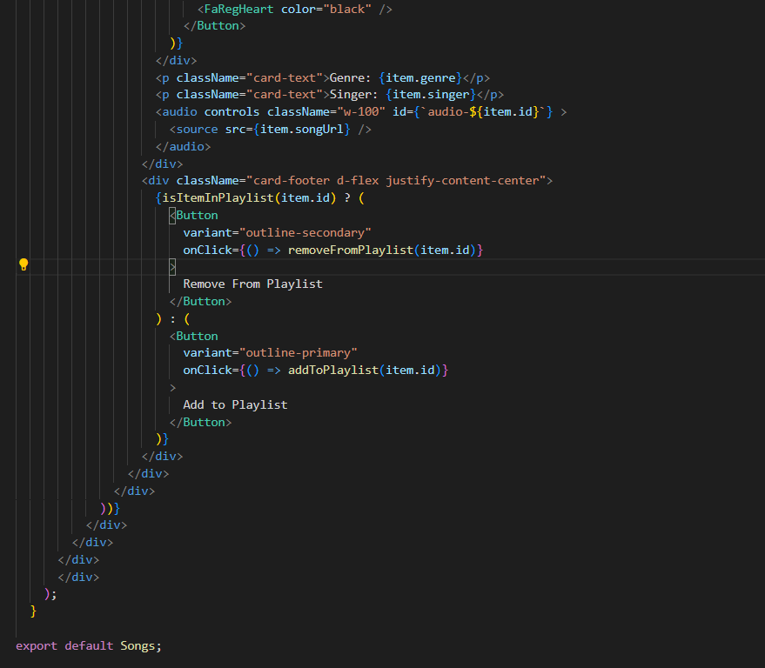

**Project structure:**

The project structure can vary based on the chosen library, framework, programming language, or development approach. Organizing files and directories in a logical and consistent manner is crucial for enhancing code maintainability and facilitating collaboration among developers.

In this project, app/app.component.css and src/app/app.component are integral parts of the main AppComponent, which serves as the root component of the React application. This component manages the overall layout and incorporates a router outlet to dynamically load different components based on the current route.

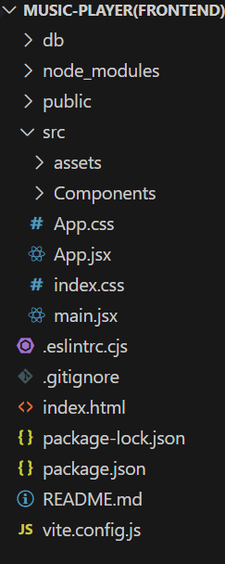

**Project Implementation:**

1. **Routing Setup:** Implemented using react-router-dom to enable navigation.
2. **Fetching Songs:** Songs are fetched via Axios from the JSON server.
3. **Playlist & Favorites Management:** Songs can be added to or removed from playlists and favorites.
4. **Audio Playback:** Ensures that only one song plays at a time, stopping any currently playing track.
5. **Search Functionality:** Allows users to search for songs based on keywords.

**Project Flow:**

1. **User Registration & Login (Future Feature):**

* Users sign up and log in to save their playlists and preferences.

1. **Home Page:**

* Displays featured songs, trending playlists, and user recommendations.
* Users can see a dynamically updated list of newly added songs.

1. **Search & Explore:**

* Users can search for songs by title, artist, or album.
* Suggested results appear as the user types.

1. **Song Selection & Playback:**

* Clicking a song starts playback in the media player.
* Users can pause, play, skip, and adjust volume.
* Background playback continues as users navigate.

1. **Creating & Managing Playlists:**

* Users can create a new playlist, add songs, and manage the order.
* Playlists are stored locally (or saved to a user account in future updates).

1. **Favorites & User Preferences:**

* Users can mark songs as favorites for quick access.
* A “Favorites” section displays all saved songs.

1. **Offline Mode (Future Update):**

* Users can download songs for offline playback.
* Storage management options for downloaded songs.

1. **Settings & User Customization:**

* Users can change theme settings, adjust playback preferences, and manage their account.

1. **Logout & Account Management (Future Feature):**

* Users can log out and manage their account settings.

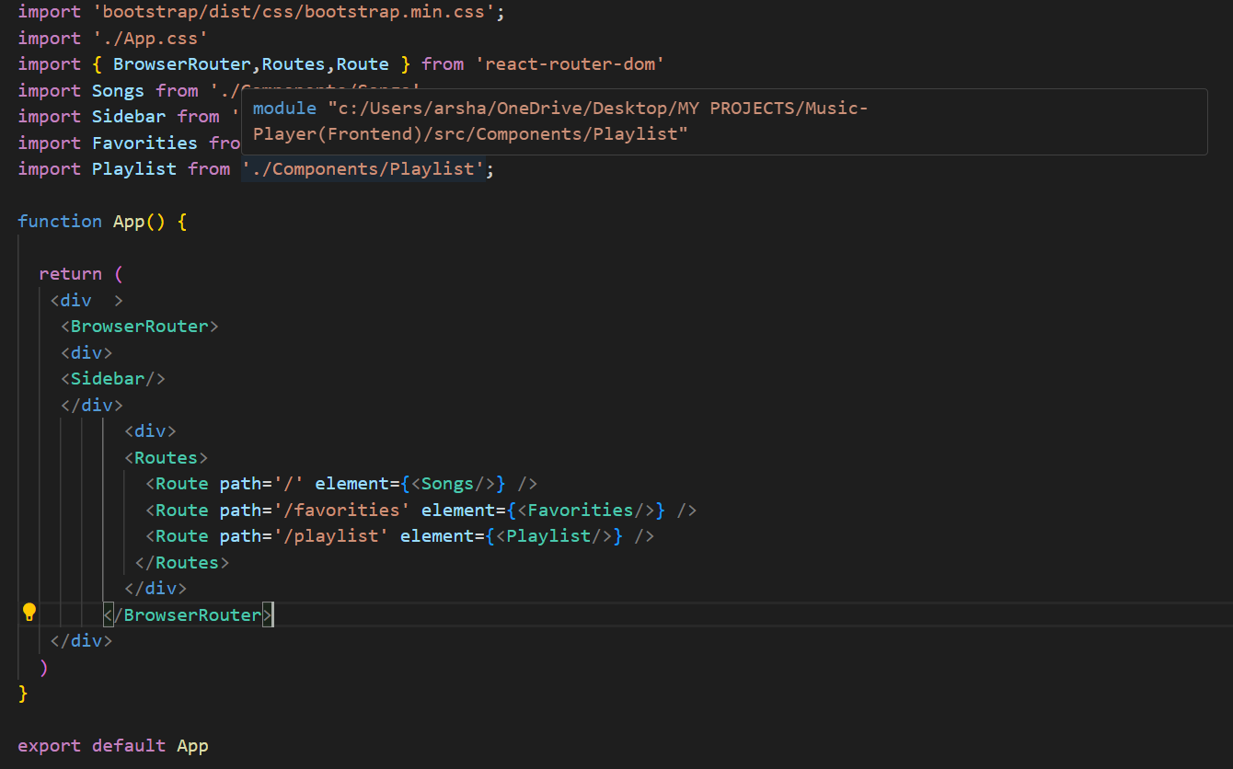

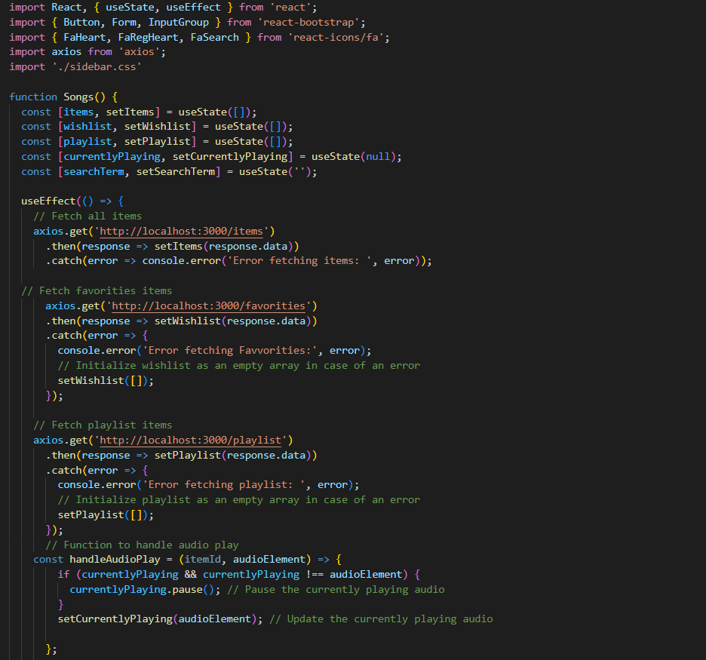

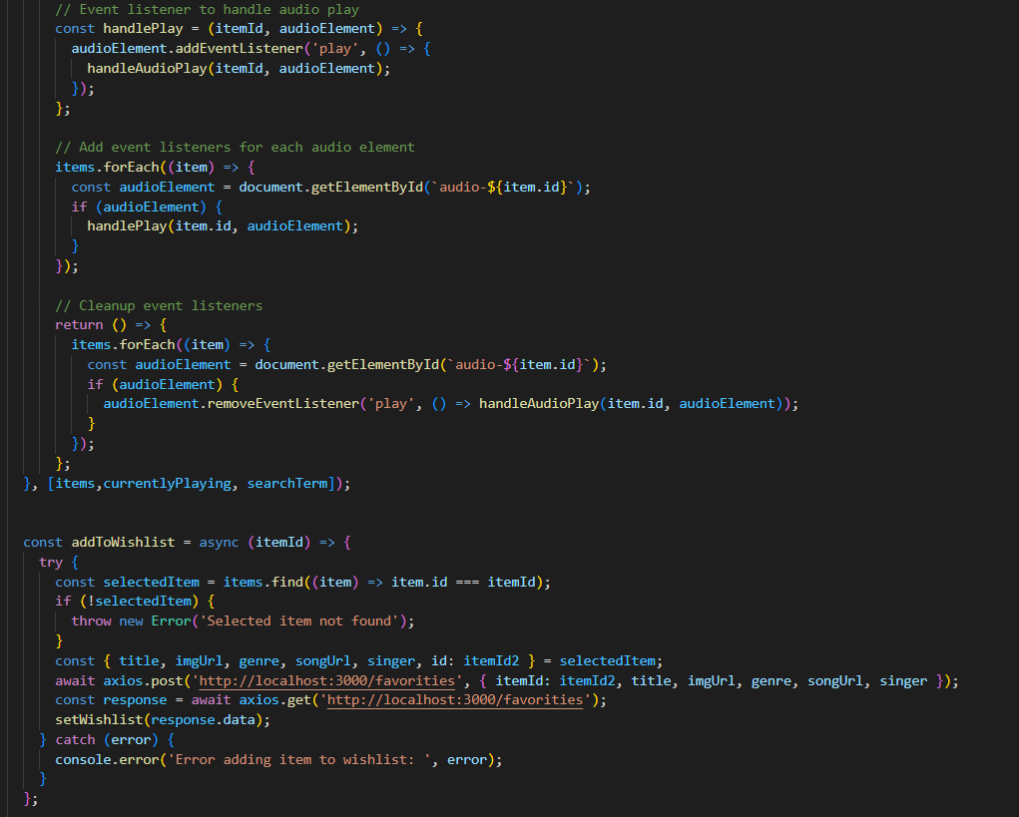

**Conclusion:**

RhythmicTunes successfully integrates modern web technologies to offer a seamless and engaging music streaming experience. By leveraging React.js and JSON Server, it provides a lightweight yet powerful platform for users to enjoy their favorite music effortlessly.

The project showcases a robust set of features, including real-time playback controls, playlist management, and search functionality, making it a versatile solution for music lovers. The incorporation of a dynamic UI ensures smooth navigation, while the structured data flow allows efficient music organization.

One of the key strengths of RhythmicTunes is its scalability. Future iterations of the application can integrate advanced functionalities such as **AI-driven music recommendations**, **user authentication**, and **cloud-based song storage**. These enhancements would further elevate the user experience, making the application more competitive in the market.

Additionally, the project adheres to best development practices, ensuring code maintainability and scalability. By using GitHub for version control and tools like Netlify or Vercel for deployment, RhythmicTunes is well-positioned for continuous updates and feature enhancements.

In conclusion, RhythmicTunes is a well-structured, modern, and feature-rich music streaming platform that caters to the evolving needs of digital music consumers. With future improvements, it has the potential to become a comprehensive music hub that seamlessly blends technology with user-centric features.

